# CAN MICROFINANCE INSTITUTIONS ACHIEVE BOTH FINANCIAL SUSTAINABILITY AND SOCIAL MISSION? AN EVALUATION USING AFRICA’S MICROFINANCE DATA

## Introduction

In this section, we examine the factors behind the simultaneous achievement (or failure to achieve) both financial and social objectives by microfinance institutions (MFIs) in Africa. MFIs are hybrid organisations that derive their legitimacy from their quest to avail financial services to the population underserved by mainstream financial intermediaries (Adams and Vogel, 2016, Morduch, 1999, Morduch, 2000). The paradigm shift towards financial sustainability means that, increasingly, the strategies adopted by MFIs must also factor in profit-making over and above availing reaching out to the financially excluded (Abeysekera et al., 2014, Awaworyi Churchill, 2018).

Available literature regarding the ability of MFIs to balance between financial viability and social mission is not conclusive. While some researchers from the welfare school hold that financial sustainability is incompatible with the social mission of MFIs (Ledgerwood and White, 2006, Rhyne and Christen, 1999, Louis and Baesens, 2013), scholars from the financial systems school think otherwise (Hartarska and Mersland, 2012, Bos and Millone, 2015) - with scholars and practitioners from each school of thought laying out empirical evidence in support (D’Espallier et al., 2017, Ledgerwood and White, 2006). The third, win-win school deems it possible the pursuit of profits and social mission (Kodongo and Kendi, 2013). However, Morduch and Ogden (2018) argue that if there were no mission drift between financial sustainability and social mission in MFIs, then NGOs would not exist, a view that supports the welfare school.

The downside of the financial systems approach is the possibility of mission drift, where the MFI emphasises financial sustainability at the expense of the social mission of outreach to the poor and the financially excluded (Beisland et al., 2017, Forkusam, 2014). On the other hand, some researchers from the school argue that MFIs could serve relatively well-off clients at market rates and then use the proceeds to subsidise the provision of financial services to the poor and expand outreach, leading to mission expansion (Mersland and Strøm, 2010, Bos and Millone, 2015). Crucially, MFIs that fail socially risk their legitimacy in the eyes of donors and society. It means, then that it becomes difficult to attract donations and subsidies (Ramus and Vaccaro, 2017). If socially failed MFIs also fail financially, then their capacity as a going concern is questionable.

Although the ongoing debate is informative, we postulate that there are factors beyond the control of MFIs that determine the extent of financial sustainability and outreach; be a social success while failing financially and vice versa, achieve both goals simultaneously or fail in both. The objective of this article is to examine the factors that determine the simultaneous achievement (or failure to achieve) financial and social objectives by MFIs using a sample of 705 MFIs in Africa. The article contributes to the literature on mission drift versus mission expansion for transformed MFIs.

## Method

We use the multinomial logit model to examine the drivers of the achievement of financial and social objectives by MFIs. The multinomial logit (Mlogit) model is an extension of the binary logit model to more than two unordered levels (discrete choices). The data at hand meets the requirements for running a Mlogit model as the dependent variable (the achievement of financial and social objectives by an MFI- see table 1) has one outcome for each case. Also, the independent variables (see Table 2 for a description) do not faultlessly predict the dependent variable.

Suppose we have a dependent variable Y consisting of K choices for K>=2. Further, let the independent variables be $X_{1}$, $X_{2}$,………. $X_{n}$, then we can specify the multinomial logit model as follows.

$$Log\left(\frac{Pr⁡(Y=k|X}{Pr⁡(Y=K|X}\right)= B_{0}^{k}+B_{1}^{k}X_{1}+………………. +B_{p}^{k}X_{p}$$

For k=0, 1, 2, ……… K-1

Y is the dependent variable, in this case, the extent to which an MFI meets its financial and social objectives.

$X_{n}$ represents the vector of independent variables.

If K>2, then we have a multinomial logit with K-1 set of equations. Where K=2, the model is the binary logit model with one equation. Note that in this case, we have arbitrarily assigned the last category (K) as the reference. Any other category can serve as a reference and will hence not be part of the set of equations.

One of the significant drawbacks of the multinomial logit is the violation of the assumption of the independence of irrelevant alternatives (IIA). Cheng and Long (2007) illustrate this assumption using the blue bus- red bus example. If the choice between car transport and a red bus, and given that the probability of choosing a bus is 0.8, and 0.2 for a car, then the odds of the bus over car transport is 4.

Suppose we introduce a third alternative, the blue bus. If the probability of choosing a red bus, blue bus, and car transport are 0.6, 0.25, 0.15 respectively, then the assumption holds since the odds of choosing red bus over a car are still 4. If the odds are different from 4, then the model violates the IIA, and the multinomial model is not fit for the data. In our case, we plausibly see the assumption holding as the achievement of either financial or social objective may reasonably be independent. We also include variables that act to control for the achievement of financial and social objectives, like the GDP growth rate at the macro-level and current legal status at the micro-level.

## The Variables and Data Sources

In our case, we construct the dependent variable by adapting the model developed by Chattopadhyay and Mitra (2017) by classifying MFIs into four categories. Category 1 consists of those MFIs that fail both financially and socially (ff), while category 2 consists of those that succeed financially but fail socially (sf), pointing at a possibility of mission drift. The third category consists of MFIs that fail financially but succeed socially (fs). MFIs that succeed both socially and financially (ss) - a sign of possible mission expansion- form the last category. Table 1 below shows the classification.

**Table 1: Dependent Variable: Financial versus social performance metrics**

|  |  |  |  |
| --- | --- | --- | --- |
|  | Does the MFI Achieve Social Objectives? | | |
| Does the MFI achieve Financial Objectives? |  | **Yes (1)** | **No (0)** |
| **Yes (1)** | *Category 4 (ss)*  This category points to MFIs from which mission expansion could arise. This class is the ideal scenario for the financial sustainability school, although its viability is controversial. | *Category 2 (sf)*  This category contains MFIs that are subject to mission drift. These MFIs risk their legitimacy but could survive as they operate a commercial model like Banks. |
|  |  |  |
| **No**  **(0)** | *Category 3 (fs)*  The welfare approach (NGO-Model) subscribes to this approach. However, some NGOs do turn profits. | *Category 1 (ff)*  While in this category, MFIs risk losing legitimacy, fail to attract donations, subsidies, and being loss-making ultimately collapse. |

Source: Adapted from Chattopadhyay and Mitra (2017)

We measure financial performance using the operational self-sufficiency (OSS) data from the Microfinance Information Exchange (MIX) pooled database. If OSS>=1, then the MFI is financially sustainable, otherwise it is not. Financially unsustainable MFIs get a code of 0, and one (1) otherwise.

$$OSS =\frac{Operating Revenue}{Expenses on (Funding, Loan loss provision and operations)}$$

On the other hand, we base social efficiency on the percentage of gross loans that go to women. If at least 50% of the gross loans accrue to women, then we consider the MFI a social success with a code of one (1) and zero otherwise. Researchers have also used the percentage of loans to rural dwellers, but data limitations do not allow for this choice. However, given the absolute number of women in poverty in Africa, the metric reasonably represents the degree of social achievement.

Table 2 below describes the independent variables.

**Table 2: Description of Independent Variables**

|  |
| --- |
| **INDEPENDENT VARIABLES** |
| **Age:** The period in which the MFI has been in operation. MIX classifies MFIs into three groups; new, young, and mature. The variable enters the model as a dummy. |
| **Size:** We proxy the size of MFI with the natural logarithm of total assets, again using data from MIX. |
| **Capital Market Development / Financial Development (CAP):** We construct an index that captures both the quality and quantity of the financial sector of individual countries. We follow the procedure similar to that of Ito and Kawai (2018) by taking the first principal component index composed of bank credit, public and private debt market, and the stock market. The data source is the GFDD of the World Bank (See note 4). |
| **Legal Tradition (Legal):** The indicator is a dummy variable with common law countries coded 0, civil law countries 1, and 2 otherwise as per the classification by Oto-Peralías and Romero-Ávila (2014). |
| **GDP annual growth rate (GDP):** This is the year on year growth in output adjusted for inflation and sourced from the WDI (See note 2). |
| **Region:** As per the African Union (AU) classification, we allocate dummy variables to each of Africa’s regions; Eastern Africa, Central Africa, Southern Africa, West Africa, and North Africa. However, we exclude the African Diaspora in our analysis. Please refer to the AU handbook at <https://au.int/en/handbook> for the details. |
| **Governance/ Institutional Quality (KKM):** We take the first principal component of the WGI developed by Daniel [Kaufmann, Aart Kraay, and Massimo Mastruzzi](http://siteresources.worldbank.org/DEC/Resources/ResponseToKnackLangbein.pdf) (KKM) (See note 3). |
| **Education (EDUC):** The indicator is a ratio of the gross enrolment in secondary school to the gross primary school enrolment as defined in the literature (Allen et al., 2014, Allen et al., 2013). |
| **Current Legal status:** We assign codes to each of the MFI legal types; NGOs, NBFIs, Credit unions/ Cooperatives, Rural Banks,and others.The data comes from MIX. |
| **Notes:**   1. The Microfinance Information Exchange (MIX) data on microfinance institutions across the globe, [www.themix.org](http://www.themix.org). 2. The World Development Indicators (WDI) database of the World Bank is available at, <https://databank.worldbank.org/source/world-development-indicators>. 3. The Worldwide Governance Indicators (WGI), of the World Bank, is available at <https://databank.worldbank.org/source/worldwide-governance-indicators>. 4. Global Financial Development Database of the World Bank available at <https://www.worldbank.org/en/publication/gfdr/data/global-financial-development-database> |

## Preliminary Output

In this section, we present the results of the model. We start with descriptive statistics by tabulating the summary statistics and correlation matrix. Next, we show the results of stationarity tests for the variables. We then visualise the data on various bases and make comparisons. Lastly, we show the results of the regression, followed by a discussion of the results.

**Descriptive Statistics**

**Table 3: Descriptive Statistics and Correlation Matrix**

|  |  |  |  |  |  |  |  |  |  |  |  |  |  |  |  |  |
| --- | --- | --- | --- | --- | --- | --- | --- | --- | --- | --- | --- | --- | --- | --- | --- | --- |
| Variables | | Obs | | Mean | SD | Min | Max | (1) | (2) | (3) | (4) | (5) | (6) | (7) | (8) | (9) |
| 1. Financial- social Performance (finsoc1) | | 4,119 | | 3.76 | 1.09 | 2 | 5 | - |  |
| (1) Age | | 4,918 | | 1.70 | 0.83 | 1 | 3 | 1.00 |  |
| (2) Region | | 4,918 | | 3.50 | 1.55 | 1 | 5 | 0.00 | 1.00 |  |
| (3) Size (lassets) | | 4,738 | | 14.88 | 2.26 | 0.14 | 22.98 | -0.32 | -0.14 | 1.00 |  |
| (4) GDP Growth | | 4,918 | | 5.30 | 3.85 | -52.43 | 33.63 | 0.03 | -0.03 | -0.04 | 1.00 |  |
| (5) Institutional Quality (dkkm) | | 3,788 | | -0.02 | 0.19 | -0.93 | 1.04 | -0.02 | -0.00 | 0.02 | 0.04 | 1.00 |  |
| (6) Education (deduc) | | 3,786 | | 0.01 | 0.03 | -0.30 | 0.27 | -0.05 | 0.02 | 0.00 | 0.01 | -0.03 | 1.00 |  |
| (7) Financial Development (fd_no_mfi) | | 4,918 | | -0.09 | 0.73 | -0.41 | 7.94 | 0.01 | -0.14 | 0.03 | -0.05 | -0.03 | 0.04 | 1.00 |  |
| (8) Legal Tradition | | 4918 | | 1.79 | 0.75 | 1 | 3 | 0.09 | -0.41 | 0.01 | 0.22 | -0.04 | -0.02 | 0.07 | 1.00 |  |
| (9) Current Legal Status | | 4918 | | 2.85 | 1.14 | 1 | 6 | -0.04 | -0.00 | -0.08 | 0.00 | 0.05 | -0.04 | -0.12 | 0.05 | 1.00 |
|  |  | |  |  |  |  | | | | | | | | | | |  |
| **Notes:**   1. MFIs get a financial-social performance code depending on the extent they meet financial and social performance targets as described in the main text. 2. There is a high correlation between the following; 3. Size of MFI and age- with the older MFIs having more assets than the relatively young ones. 4. Legal tradition and region are correlated, with legal traditions clustered in regions. For instance, most of Eastern and Southern Africa follows common law with some exceptions of, among others, Madagascar, Mozambique, Ethiopia, and Rwanda. Likewise, West Africa is predominantly of civil law tradition- with notable exceptions like Nigeria and Ghana. 5. We run a pooled multinomial logit/probit. The resultant variance inflation factors mean that multi-collinearity is not a significant problem. 6. We also run regressions that exclude size and legal tradition where both age and region are still significant. 7. Another solution to multi-collinearity is to have a large sample size. Some researchers suggest a ratio of 50 to 100 observations per independent variable. In this case, we have a maximum of 3400 observations that exceed the threshold. 8. An extended table of descriptive statistics for the panel dataset is in the appendix (). | | | | | | | | | | | | | | | |  |

**Source: Authors’ Construction**

**Table 4: Stationarity Tests for Variables**

|  |  |  |  |  |  |
| --- | --- | --- | --- | --- | --- |
| We ran the Fisher type unit root tests based on the augmented Dickey-Fuller tests of stationarity that can handle instances of missing data points in a panel setting. The variable total assets (for the size of MFI) was not stationary, but the natural logarithm (lassets), was. Further, we transformed education and institutional quality by taking the first difference.  **Hypotheses: HO:** All panels contain unit-roots.  **H1:** At least one panel is stationary. | | | | | |
|  | Size (lassets) | GDP Growth | Institutional  Quality (dkkm) | Education  (deduc) | Financial Development ((fd_no_mfi) |
| Inverse chi-squared P | 2074.3879*** | 3511.7077*** | 2896.9486*** | 3755.3928*** | 2265.7956*** |
| Inverse normal Z | -1.4296* | -24.1974*** | -26.3351*** | -35.2380*** | -8.1455*** |
| Inverse logit L* | -14.0485*** | -42.9106*** | -40.6264*** | -56.2766*** | -18.9831*** |
| Modified inv. chi-squared Pm | 17.6817**** | 44.7045*** | 47.1681*** | 67.4244*** | 19.9246*** |
| 1. The AR parameter for the test is panel specific. Additionally, we include panel means and a time trend but no drift term. 2. The other variables absent in the unit root test are dummies- current legal status, age, region, and legal tradition. | | | | | |

**Source:** Authors’ constructions from the data

|  |  |  |  |
| --- | --- | --- | --- |
| *G*roup(finsoc*1)* | *Freq.* | *%* | *Cum. (%)* |
| ff (see note below) | 649 | 15.76% | 15.76% |
| fs | 1,098 | 26.66% | 42.41% |
| sf | 958 | 23.26% | 65.67% |
| ss | 1,414 | 34.33% | 100.00% |
| Total | 4,119 | 100.00% |  |
| **Note:** The coding for the financial- social performance (finsoc1) starts with the financial performance followed by social performance. F stands for failure while S denotes success. For instance, the code ff means that the MFI fails both financially and socially in that order. On the other hand, sf means the MFI succeeds financially but fails socially. | | | |

**Table 5: Summary figures by levels of Financial and Social Performance**

Table 3 shows that, at 34%, most MFIs in Africa that submit data to the MIX pooled database tend to succeed both financially and socially. 23% succeed financially but fail socially, while 27% emphasise the social mission while failing financially.

Figure 1: Financial and Social Performance of MFIs by legal Status of MFI

As figure 1 shows, for MFIs in Africa that fail both socially and financially, most are credit unions/ cooperatives followed by Non-Bank-Financial Institutions (NBFIs). Credit unions/ Cooperatives are also the most likely to succeed financially but fail socially, again followed by NBFIs. The pattern probably shows the business model of MFIs that focuses on members of groups with common interests, like sharing employers, and hence where the emphasis on social performance comes second to serving members. NGOs have the highest incidence of achieving the twin objectives of financial and social performance, followed by, ironically, NBFIs and credit unions/ cooperatives. Also, NGOs have a higher frequency of failing socially but tend to succeed financially, and hence reflecting their subscription to the welfare school.

Figure 2 below shows the performance of MFIs by region. In North Africa, 64% of MFIs meet both financial and social performance objectives, the highest rate, followed by West Africa, Eastern Africa, and Central Africa. It is notable that data for North Africa has NGOs only, perhaps due to the cultural and religious background. At 49.6%, MFIs in Southern Africa have the highest rate of meeting social performance while failing financially, a rate twice as high as that of West Africa. It means that most MFIs in Southern Africa follow the welfare approach. For MFIs that fail financially but succeed socially, MFIs in Central Africa lead followed by Eastern Africa while Southern Africa comes last. Finally, MFIs in central Africa have the highest rate of social and financial failure at 24% followed by West Africa at 17%. North Africa has the lowest rate of 4.76%. Overall MFIs in North Africa operate as NGOs exclusively do better- with the highest rates of meeting both financial and social performance while having the lowest rates of meeting both targets.

Figure 2: Financial and Social Performance of MFIs by Region- Columnar

We also break down the data by legal tradition in Table 3 below. The analysis shows that it is MFIs located in civil law countries that have the highest frequency of concurrent financial and social failure while those in common law countries have the least. On the other hand, MFIs in common law countries have the highest instance of simultaneous financial and social success, while those in the civil law countries have the least. MFIs located in countries with other legal traditions sit in the middle with the distribution of performance distributed almost evenly. However, for common law countries, there is a higher frequency of financial failure with social success. Civil law countries exhibit higher rates of mission drift- financial success with social failure.

Figure 3: Financial and Social Performance of MFIs by Legal Tradition

The source of the disparity between the financial and social performance of MFIs by legal tradition is not apparent. The next section shows the results of the regression, which could uncover some of these insights.

### The output of the Regression Model

Appendix 5 shows the output from the regression. Age, size, region, GDP growth, legal tradition, and legal status of an MFI are significant determinants of the likelihood of MFIs meeting financial and social objectives. Note that we have used MFIs that succeed both financially and socially (SS) as the base, which is an arbitrary choice as any other category would do.

* MFIs that fail both financially and socially (ff): The older the MFIs, the lower the chance of failing to meet both objectives compared to the younger ones. In statistical terms, an increase in age lowers (due to the negative sign) the odds of being in the ff category as compared to the ss category (the base). Also, MFIs in Southern Africa are more likely to fail to meet both objectives (ff) than to meet them (ss) compared to other regions. The opposite is the case for West Africa and North Africa. Although not significant, MFIs in Central Africa are more likely to fail financially, and socially than they are to succeed. MFIs operating in countries with high growth rates have a lower chance of failing to meet both objectives than to meet both. Also, countries in civil law countries are more likely to fail in meeting both objectives than to meet them. MFIs in other legal traditions are more likely to fail financially and socially, although the relationship is not significant. Lastly, NGOs are less likely to fail in both objectives than to meet them. The same is true for rural banks although the relationship is not statistically significant. NBFIs, Credit Unions/ Cooperatives, and other legal forms are all more likely to fail in both objectives, but the relationship is not significant.

Institutional quality (KKM), financial development (FD), and education are not significant in determining the degree of meeting financial and social objectives. Both KKM and FD are positively related to the possibility of MFIs failing financially and socially. The result could be due to the competition that MFIs face from the mainstream financial sector. Education lowers the probability of failing.

* MFIs that fail financially but succeed socially (fs): The following variables positively and significantly raise the probability that an MFI fails financially but socially succeeds instead of succeeding in both: MFIs operating in Southern Africa, MFIs operating in civil law countries, and MFIs that are NBFIs. However, other factors that raise the probability of an MFI being in this category but are not statistically significant. These are financial development and MFIs that operate as credit unions/ cooperatives, NGOs, and others. On the other hand, the following factors negatively and significantly lower the probability of an MFI failing financially but succeeding socially: Age, MFIs in central and North Africa, size, MFIs in countries with other legal traditions, and MFIs operating as rural banks. Although not significant, the following factors also lower the probability of an MFI being fs as opposed to ss: MFIs operating in West Africa, institutional quality and education. This category is indicative of mission drift.
* MFIs that succeed financially but fail socially (sf): The following factors significantly raise the probability that an MFI will succeed financially but fail socially: MFIs located in Central Africa and civil law countries, size of an MFI, and MFIs operating as credit unions and rural banks. The following factors also raise this probability but not significantly so: age (young MFIs), education, financial development, MFIs in countries with other legal traditions and Non-Bank Financial Institutions (NBFIs). On the other hand, the following factors lower the probability of an MFI being in the sf category (failing financially, succeeding socially) as opposed to the ss category significantly: MFIs in West Africa, NGOs and rural banks. The following factors lower the probability of an MFI being in the sf category instead of ss category but not significantly: age (mature MFIs), MFIs in North and Southern Africa, GDP growth, Institutional quality, and MFIs operating other organisational structures.

In the marginsplots that follow, we show how the significant variables affect the probability for each outcome. For instance, figure 1 shows how each of the key variables affects the probability of an MFI failing both financially and socially. Subsequent graphs show outcomes for the other scenarios as described above.

Figure 4: Adjusted Predictions at 95% Confidence Intervals for category ff (FF- MFIs that fail both financially and socially)

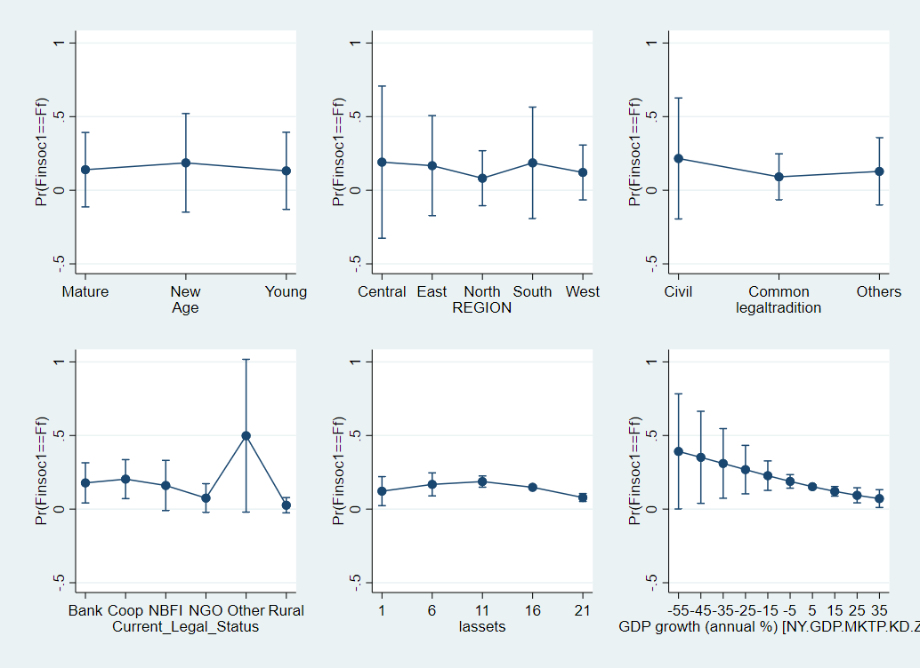

Figure 5: Adjusted Predictions at 95% Confidence Intervals for category fs (FS- MFIs that fail financially and succeed socially)

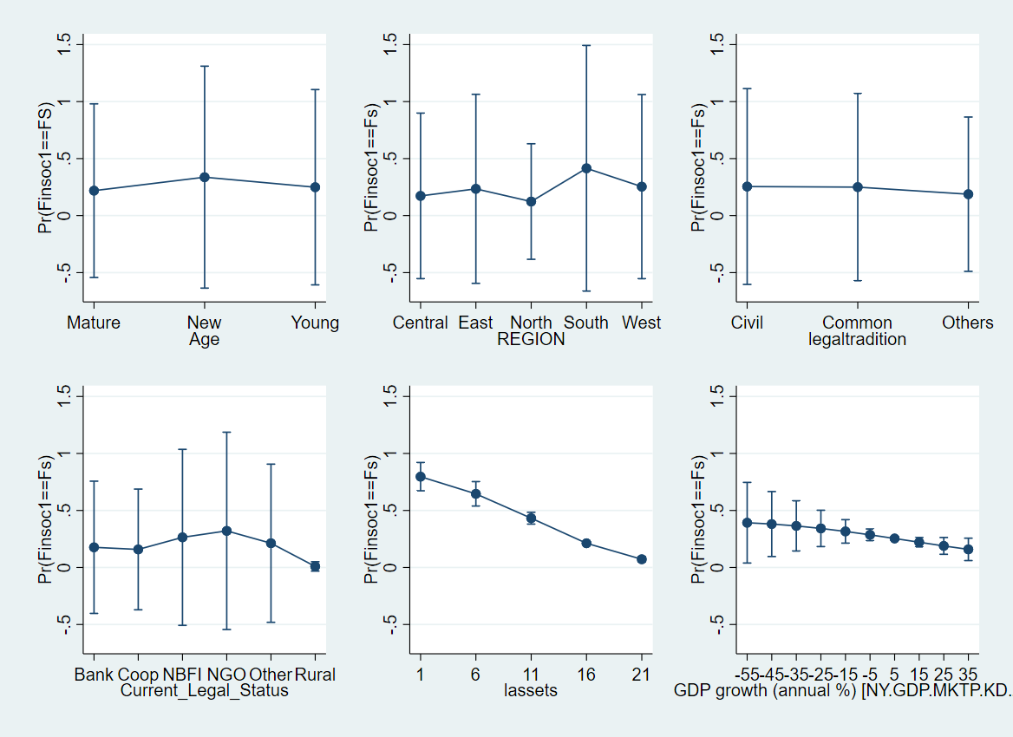

Figure 6: Adjusted Predictions at 95% Confidence Intervals for category sf (SF- MFIs that succeed financially and fail socially)

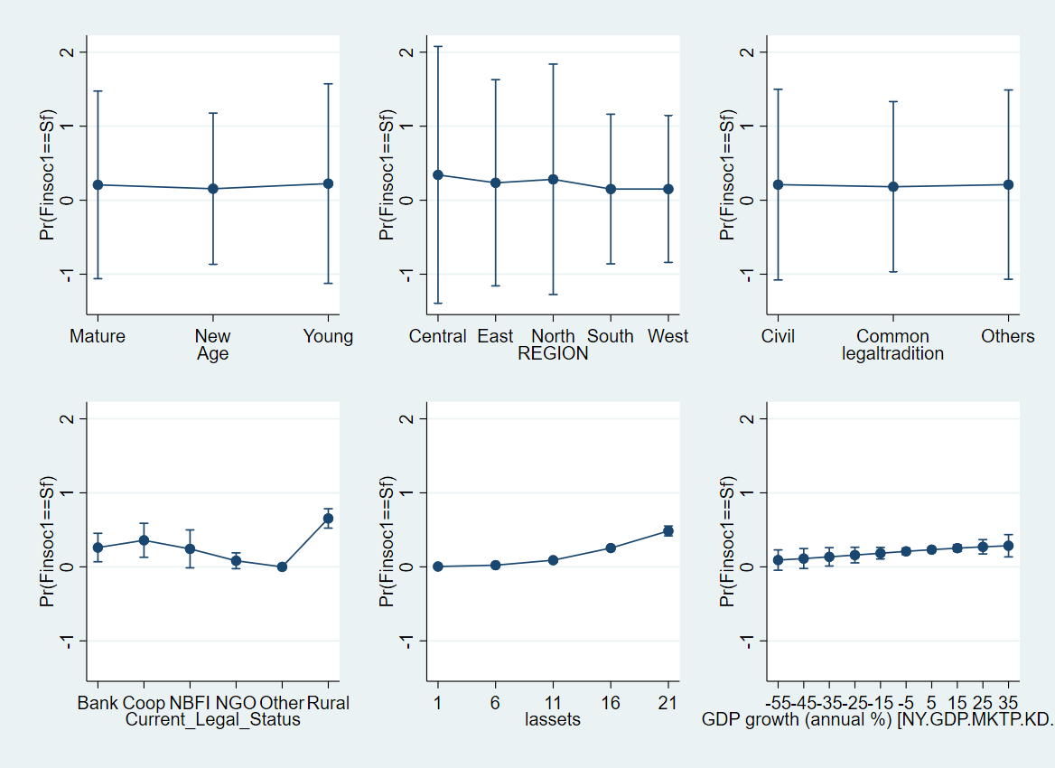

Figure 7: Adjusted Predictions at 95% Confidence Intervals for category ss (SS- MFIs that succeed both financially and socially)

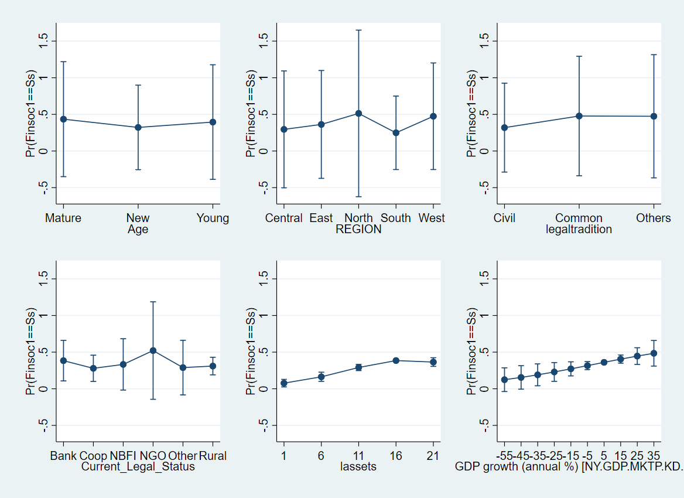

# References

ABEYSEKERA, S., OGUZOGLU, U. & LE, T. 2014. Sustainability and mission drift: Do microfinance institutions in Vietnam reach the poor? *In:* MERSLAND, R. & STRØM, R. Ø. (eds.) *Microfinance institutions: Financial and social performance.* London: Palgrave Macmillan UK.

ADAMS, D. W. & VOGEL, R. C. 2016. Microfinance dreams. *Enterprise Development and Microfinance,* 27**,** 142-154.

ALLEN, F., CARLETTI, E., CULL, R., QIAN, J. Q., SENBET, L. & VALENZUELA, P. 2013. *Resolving the African financial development gap: Cross-country comparisons and a within-country study of Kenya,* New York, The World Bank.

ALLEN, F., CARLETTI, E., CULL, R., QIAN, J. Q., SENBET, L. & VALENZUELA, P. 2014. The African financial development and financial inclusion gaps. *Journal of African economies,* 23**,** 614-642.

AWAWORYI CHURCHILL, S. 2018. Sustainability and depth of outreach: Evidence from microfinance institutions in sub‐Saharan Africa. *Development Policy Review,* 36**,** O676-O695.

BEISLAND, L. A., D’ESPALLIER, B. & MERSLAND, R. 2017. The Commercialization of the Microfinance Industry: Is There a ‘Personal Mission Drift’ Among Credit Officers? *Journal of Business Ethics,* 146**,** 22-40.

BOS, J. W. & MILLONE, M. 2015. Practice what you preach: Microfinance business models and operational efficiency. *World Development,* 70**,** 28-42.

CHATTOPADHYAY, M. & MITRA, S. 2017. Applicability and effectiveness of classifications models for achieving the twin objectives of growth and outreach of microfinance institutions. *Computational Math and Organization Theory,* 23**,** 451–474.

CHENG, S. & LONG, J. S. 2007. Testing for IIA in the multinomial logit model. *Sociological methods & research,* 35**,** 583-600.

D’ESPALLIER, B., GOEDECKE, J., HUDON, M. & MERSLAND, R. 2017. From NGOs to banks: Does institutional transformation alter the business model of microfinance institutions? *World Development,* 89**,** 19-33.

FORKUSAM, A. N. 2014. Does financial globalization affect microfinance mission drift? *In:* MERSLAND, R. & STRØM, R. Ø. (eds.) *Microfinance institutions: Financial and social performance.* London: Palgrave Macmillan UK.

HARTARSKA, V. & MERSLAND, R. 2012. Which governance mechanisms promote efficiency in reaching poor clients? Evidence from rated microfinance institutions. *European Financial Management,* 18**,** 218-239.

ITO, H. & KAWAI, M. 2018. Quantity and Quality Measures of Financial Development: Implications for Macroeconomic Performance. *Public Policy Review,* 14**,** 803-834.

KODONGO, O. & KENDI, L. G. 2013. Individual lending versus group lending: An evaluation with Kenya's microfinance data. *Review of Development Finance,* 3**,** 99-108.

LEDGERWOOD, J. & WHITE, V. 2006. *Transforming microfinance institutions: providing full financial services to the poor,* New York, World Bank Publications.

LOUIS, P. & BAESENS, B. 2013. Do for-profit microfinance institutions achieve better financial efficiency and social impact? A generalised estimating equations panel data approach. *Journal of Development Effectiveness,* 5**,** 359-380.

MERSLAND, R. & STRØM, R. Ø. 2010. Microfinance mission drift? *World Development,* 38**,** 28-36.

MORDUCH, J. 1999. The microfinance promise. *Journal of economic literature,* 37**,** 1569-1614.

MORDUCH, J. 2000. The microfinance schism. *World development,* 28**,** 617-629.

MORDUCH, J. & OGDEN, T. 2018. Social Investment Through the Lens of Microfinance. *In:* HUDON, M., LABIE, M. & SZAFARZ, A. (eds.) *Research Agenda in Financial Inclusion and Microfinance.* New York: Routledge.

OTO-PERALÍAS, D. & ROMERO-ÁVILA, D. 2014. The distribution of legal traditions around the world: a contribution to the legal-origins theory. *The Journal of Law and Economics,* 57**,** 561-628.

RAMUS, T. & VACCARO, A. 2017. Stakeholders matter: How social enterprises address mission drift. *Journal of Business Ethics,* 143**,** 307-322.

RHYNE, E. & CHRISTEN, R. 1999. *Microfinance enters the marketplace,* New York, USAID.

# Appendices

Appendix 1: Tabulation financial and social performance by region

Appendix 2: Tabulation financial and social performance by the current legal status of MFIs

|  |  |  |  |  |  |  |  |
| --- | --- | --- | --- | --- | --- | --- | --- |
| Legal Status | Bank | Credit Union | NBFI | NGO | Other | Rural bank | Total |
| Finsoc1 |  |  |  |  |  |  |  |
| ff | 50 | 308 | 195 | 90 | 5 | 1 | 649 |
|  | 7.70% | 47.46% | 30.05% | 13.87% | 0.77% | 0.15% | 100.00% |
|  |  |  |  |  |  |  |  |
| fs | 73 | 221 | 335 | 458 | 8 | 3 | 1,098 |
|  | 6.65% | 20.13% | 30.51% | 41.71% | 0.73% | 0.27% | 100.00% |
|  |  |  |  |  |  |  |  |
| sf | 121 | 385 | 281 | 119 | 0 | 52 | 958 |
|  | 12.63% | 40.19% | 29.33% | 12.42% | 0.00% | 5.43% | 100.00% |
|  |  |  |  |  |  |  |  |
| ss | 137 | 253 | 328 | 631 | 5 | 60 | 1,414 |
|  | 9.69% | 17.89% | 23.20% | 44.63% | 0.35% | 4.24% | 100.00% |
|  |  |  |  |  |  |  |  |
| Total | 381 | 1,167 | 1,139 | 1,298 | 18 | 116 | 4,119 |
|  | 9.25% | 28.33% | 27.65% | 31.51% | 0.44% | 2.82% | 100.00% |

Appendix 3: Tabulation financial and social performance by legal traditions

|  |  |  |  |  |
| --- | --- | --- | --- | --- |
| Legal tradition | Civil Law | Common-Law | Others | Total |
| Finsoc1 |  |  |  |  |
| ff | 380 | 128 | 141 | 649 |
|  | 58.55% | 19.72% | 21.73% | 100.00% |
|  |  |  |  |  |
| fs | 423 | 483 | 192 | 1,098 |
|  | 38.52% | 43.99% | 17.49% | 100.00% |
|  |  |  |  |  |
| sf | 418 | 301 | 239 | 958 |
|  | 43.63% | 31.42% | 24.95% | 100.00% |
|  |  |  |  |  |
| ss | 497 | 610 | 307 | 1,414 |
|  | 35.15% | 43.14% | 21.71% | 100.00% |
|  |  |  |  |  |
| Total | 1,718 | 1,522 | 879 | 4,119 |
|  | 41.71% | 36.95% | 21.34% | 100.00% |

|  |  |  |  |  |  |  |
| --- | --- | --- | --- | --- | --- | --- |
|  | Central Africa | Eastern Africa | North Africa | Southern Africa | West Africa | Total |
|  |  |  |  |  |  |  |
| ff | 110 | 172 | 15 | 49 | 303 | 649 |
|  | 24.18% | 14.64% | 4.76% | 12.93% | 16.88% | 15.76% |
|  |  |  |  |  |  |  |
| fs | 89 | 283 | 47 | 188 | 491 | 1,098 |
|  | 19.56% | 24.09% | 14.92% | 49.60% | 27.35% | 26.66% |
|  |  |  |  |  |  |  |
| sf | 165 | 337 | 51 | 46 | 359 | 958 |
|  | 36.26% | 28.68% | 16.19% | 12.14% | 20.00% | 23.26% |
|  |  |  |  |  |  |  |
| ss | 91 | 383 | 202 | 96 | 642 | 1,414 |
|  | 20.00% | 32.60% | 64.13% | 25.33% | 35.77% | 34.33% |
|  |  |  |  |  |  |  |
| Total | 455 | 1,175 | 315 | 379 | 1,795 | 4,119 |
|  | 100.00% | 100.00% | 100.00% | 100.00% | 100.00% | 100.00% |

Appendix 4: Summary Statistics for Panel dataset (Extended)

|  |  |  |  |  |  |  |
| --- | --- | --- | --- | --- | --- | --- |
| **Variable** |  | **Mean** | **Std. Dev.** | **Min** | **Max** | **Observations** |
|  |  |  |  |  |  |  |
| Financial-Social | overall | 3.7616 | 1.0879 | 2 | 5 | N = 4119 |
| Performance (Finsoc1) | between |  | 0.8753 | 2 | 5 | n = 632 |
|  | within |  | 0.7457 | 1.1783 | 6.2616 | T-bar = 6.5174 |
|  |  |  |  |  |  |  |
| Age (Dummy) | overall | 1.6987 | 0.8327 | 1 | 3 | N = 4918 |
|  | between |  | 0.6703 | 1 | 3 | n = 911 |
|  | within |  | 0.5743 | 0.0987 | 3.5934 | T-bar = 5.3985 |
|  |  |  |  |  |  |  |
| Region (Dummy) | overall | 3.5043 | 1.5450 | 1 | 5 | N = 4918 |
|  | between |  | 1.5677 | 1 | 5 | n = 911 |
|  | within |  | 0 | 3.5043 | 3.5043 | T-bar = 5.3985 |
|  |  |  |  |  |  |  |
| Size (lassets) | overall | 14.8748 | 2.2571 | 0.1398 | 22.9786 | N = 4738 |
|  | between |  | 2.2082 | 3.0067 | 22.6132 | n = 841 |
|  | within |  | 0.8051 | 9.5202 | 19.3762 | T-bar = 5.6338 |
|  |  |  |  |  |  |  |
| GDP Growth | overall | 5.3030 | 3.8446 | -52.4275 | 33.6294 | N = 4918 |
|  | between |  | 2.3382 | -12.9446 | 14.0471 | n = 911 |
|  | within |  | 3.2785 | -46.5989 | 41.3544 | T-bar = 5.3985 |
|  |  |  |  |  |  |  |
| Institutional | overall | -0.02013 | 0.1908 | -0.9316 | 1.0440 | N = 3788 |
| Quality (dkkm) | between |  | 0.1174 | -0.7585 | 0.4112 | n = 778 |
|  | within |  | 0.1732 | -0.8930 | 0.9177 | T-bar = 4.8689 |
|  |  |  |  |  |  |  |
| Education (deduc) | overall | 0.0099 | 0.0328 | -0.2966 | 0.2685 | N = 3786 |
|  | between |  | 0.0192 | -0.1014 | 0.0946 | n = 777 |
|  | within |  | 0.0296 | -0.2830 | 0.2821 | T-bar = 4.8726 |
|  |  |  |  |  |  |  |
| Financial | overall | -0.09070 | 0.7303 | -0.4081 | 7.9411 | N = 4918 |
| development | between |  | 0.8393 | -0.4081 | 7.9411 | n = 911 |
| (fd_no_mfi) | within |  | 0.1315 | -1.4043 | 1.1936 | T-bar = 5.3985 |
|  |  |  |  |  |  |  |
| Legal Tradition | overall | 1.7869 | 0.7539 | 1 | 3 | N = 4918 |
|  | between |  | 0.7326 | 1 | 3 | n = 911 |
|  | within |  | 0 | 1.7869 | 1.7869 | T-bar = 5.3985 |
| Current Legal | overall | 0.7198 | 0.4491 | 0 | 1 | N = 4918 |
| Status (Dummy) | between |  | 0.4080 | 0 | 1 | n = 911 |
|  | within |  | 0.0130 | -0.1135 | 0.8865 | T-bar = 5.3985 |

Appendix 5: Output from the Multinomial Logit Model

|  |  |  |  |  |  |  |  |  |  |  |  |  |  |  |  |  |  |  |  |  |  |  |  |  |  |  |  |  |  |  |  |  |  |  |  |  |  |  |  |  |  |  |  |  |  |  |  |  |  |  |  |  |  |  |  |  |  |  |  |  |  |  |  |  |  |  |  |  |  |  |  |  |  |  |  |  |  |  |  |  |  |  |  |  |  |  |  |  |  |  |  |  |  |  |  |  |  |  |  |  |  |  |  |  |  |  |  |  |  |  |  |  |  |  |  |  |  |  |  |  |  |  |  |  |  |  |  |  |  |  |  |  |  |  |  |  |  |  |  |  |  |  |  |  |  |  |  |  |  |  |  |  |  |  |  |  |  |  |  |  |  |  |  |  |  |  |  |  |  |  |  |  |  |  |  |  |  |  |  |  |  |  |  |  |  |  |  |  |  |  |  |  |  |  |  |  |  |  |  |  |  |  |  |  |  |  |  |  |  |  |  |  |  |  |  |  |  |  |  |  |  |  |  |  |  |  |  |  |  |  |  |  |  |  |  |  |  |  |  |  |  |  |  |  |  |  |  |  |  |  |  |  |  |  |  |  |  |  |  |  |  |  |  |  |  |  |  |  |  |  |  |  |  |  |  |  |  |  |  |  |  |  |  |  |  |  |  |  |  |  |  |  |  |  |  |  |  |  |  |  |  |  |  |  |  |  |  |  |  |  |  |  |  |  |  |  |  |  |  |  |  |  |  |  |  |  |  |  |  |  |  |  |  |  |  |  |  |  |  |  |  |  |  |  |  |  |  |  |  |  |  |  |  |  |  |  |  |  |  |  |  |  |  |  |  |  |  |  |  |  |  |  |  |  |  |  |  |  |  |  |  |  |  |  |  |  |  |  |  |  |  |  |  |  |  |  |  |  |  |  |  |  |  |  |  |  |  |  |  |  |  |  |  |  |  |  |  |  |  |  |  |  |  |  |  |  |  |  |  |  |  |  |  |  |  |  |  |  |  |  |  |  |  |  |  |  |  |  |  |  |  |  |  |  |  |  |  |  |  |  |  |  |  |  |  |  |  |  |  |  |  |  |  |  |  |  |  |  |  |  |  |  |  |  |  |  |  |  |  |  |  |  |  |  |  |  |  |  |  |  |  |  |  |  |  |  |  |  |  |  |  |  |  |  |  |  |  |  |  |  |  |  |  |  |  |  |  |  |  |  |  |  |  |  |  |  |  |  |  |  |  |  |  |  |  |  |  |  |  |  |  |  |  |  |  |  |  |  |  |  |  |  |  |  |  |  |  |  |  |  |  |  |  |  |  |  |  |  |  |  |  |  |  |  |  |  |  |  |  |  |  |  |  |  |  |  |  |  |  |  |  |  |  |  |  |  |  |  |  |  |  |  |  |  |  |  |  |  |  |  |  |  |  |  |  |  |  |  |  |  |  |  |  |  |  |  |  |  |  |  |  |  |  |  |  |  |  |  |  |  |  |  |  |  |  |  |  |  |  |  |  |  |  |  |  |  |  |  |  |  |  |  |  |  |  |  |  |  |  |  |  |  |  |  |  |  |  |  |  |  |  |  |  |  |  |  |  |  |  |  |  |  |  |  |  |  |  |  |  |  |  |  |  |  |  |  |  |  |  |  |  |  |  |  |  |  |  |  |  |  |  |  |  |  |  |  |  |  |  |  |  |  |  |  |  |  |  |  |  |  |  |  |  |  |  |  |  |  |  |  |  |  |  |  |  |  |  |  |  |  |  |  |  |  |  |  |  |  |  |  |  |  |  |  |  |  |  |  |  |  |  |  |  |  |  |  |  |  |  |  |  |  |  |  |  |  |  |  |  |  |  |  |  |  |  |  |  |  |  |  |  |  |  |  |  |  |  |  |  |  |  |  |  |  |  |  |  |  |  |  |  |  |  |  |  |  |  |  |  |  |  |  |  |  |  |  |  |  |  |  |  |  |  |  |  |
| --- | --- | --- | --- | --- | --- | --- | --- | --- | --- | --- | --- | --- | --- | --- | --- | --- | --- | --- | --- | --- | --- | --- | --- | --- | --- | --- | --- | --- | --- | --- | --- | --- | --- | --- | --- | --- | --- | --- | --- | --- | --- | --- | --- | --- | --- | --- | --- | --- | --- | --- | --- | --- | --- | --- | --- | --- | --- | --- | --- | --- | --- | --- | --- | --- | --- | --- | --- | --- | --- | --- | --- | --- | --- | --- | --- | --- | --- | --- | --- | --- | --- | --- | --- | --- | --- | --- | --- | --- | --- | --- | --- | --- | --- | --- | --- | --- | --- | --- | --- | --- | --- | --- | --- | --- | --- | --- | --- | --- | --- | --- | --- | --- | --- | --- | --- | --- | --- | --- | --- | --- | --- | --- | --- | --- | --- | --- | --- | --- | --- | --- | --- | --- | --- | --- | --- | --- | --- | --- | --- | --- | --- | --- | --- | --- | --- | --- | --- | --- | --- | --- | --- | --- | --- | --- | --- | --- | --- | --- | --- | --- | --- | --- | --- | --- | --- | --- | --- | --- | --- | --- | --- | --- | --- | --- | --- | --- | --- | --- | --- | --- | --- | --- | --- | --- | --- | --- | --- | --- | --- | --- | --- | --- | --- | --- | --- | --- | --- | --- | --- | --- | --- | --- | --- | --- | --- | --- | --- | --- | --- | --- | --- | --- | --- | --- | --- | --- | --- | --- | --- | --- | --- | --- | --- | --- | --- | --- | --- | --- | --- | --- | --- | --- | --- | --- | --- | --- | --- | --- | --- | --- | --- | --- | --- | --- | --- | --- | --- | --- | --- | --- | --- | --- | --- | --- | --- | --- | --- | --- | --- | --- | --- | --- | --- | --- | --- | --- | --- | --- | --- | --- | --- | --- | --- | --- | --- | --- | --- | --- | --- | --- | --- | --- | --- | --- | --- | --- | --- | --- | --- | --- | --- | --- | --- | --- | --- | --- | --- | --- | --- | --- | --- | --- | --- | --- | --- | --- | --- | --- | --- | --- | --- | --- | --- | --- | --- | --- | --- | --- | --- | --- | --- | --- | --- | --- | --- | --- | --- | --- | --- | --- | --- | --- | --- | --- | --- | --- | --- | --- | --- | --- | --- | --- | --- | --- | --- | --- | --- | --- | --- | --- | --- | --- | --- | --- | --- | --- | --- | --- | --- | --- | --- | --- | --- | --- | --- | --- | --- | --- | --- | --- | --- | --- | --- | --- | --- | --- | --- | --- | --- | --- | --- | --- | --- | --- | --- | --- | --- | --- | --- | --- | --- | --- | --- | --- | --- | --- | --- | --- | --- | --- | --- | --- | --- | --- | --- | --- | --- | --- | --- | --- | --- | --- | --- | --- | --- | --- | --- | --- | --- | --- | --- | --- | --- | --- | --- | --- | --- | --- | --- | --- | --- | --- | --- | --- | --- | --- | --- | --- | --- | --- | --- | --- | --- | --- | --- | --- | --- | --- | --- | --- | --- | --- | --- | --- | --- | --- | --- | --- | --- | --- | --- | --- | --- | --- | --- | --- | --- | --- | --- | --- | --- | --- | --- | --- | --- | --- | --- | --- | --- | --- | --- | --- | --- | --- | --- | --- | --- | --- | --- | --- | --- | --- | --- | --- | --- | --- | --- | --- | --- | --- | --- | --- | --- | --- | --- | --- | --- | --- | --- | --- | --- | --- | --- | --- | --- | --- | --- | --- | --- | --- | --- | --- | --- | --- | --- | --- | --- | --- | --- | --- | --- | --- | --- | --- | --- | --- | --- | --- | --- | --- | --- | --- | --- | --- | --- | --- | --- | --- | --- | --- | --- | --- | --- | --- | --- | --- | --- | --- | --- | --- | --- | --- | --- | --- | --- | --- | --- | --- | --- | --- | --- | --- | --- | --- | --- | --- | --- | --- | --- | --- | --- | --- | --- | --- | --- | --- | --- | --- | --- | --- | --- | --- | --- | --- | --- | --- | --- | --- | --- | --- | --- | --- | --- | --- | --- | --- | --- | --- | --- | --- | --- | --- | --- | --- | --- | --- | --- | --- | --- | --- | --- | --- | --- | --- | --- | --- | --- | --- | --- | --- | --- | --- | --- | --- | --- | --- | --- | --- | --- | --- | --- | --- | --- | --- | --- | --- | --- | --- | --- | --- | --- | --- | --- | --- | --- | --- | --- | --- | --- | --- | --- | --- | --- | --- | --- | --- | --- | --- | --- | --- | --- | --- | --- | --- | --- | --- | --- | --- | --- | --- | --- | --- | --- | --- | --- | --- | --- | --- | --- | --- | --- | --- | --- | --- | --- | --- | --- | --- | --- | --- | --- | --- | --- | --- | --- | --- | --- | --- | --- | --- | --- | --- | --- | --- | --- | --- | --- | --- | --- | --- | --- | --- | --- | --- | --- | --- | --- | --- | --- | --- | --- | --- | --- | --- | --- | --- | --- | --- | --- | --- | --- | --- | --- | --- | --- | --- | --- | --- | --- | --- | --- | --- | --- | --- | --- | --- | --- | --- | --- | --- | --- | --- | --- | --- | --- | --- | --- | --- | --- | --- | --- | --- | --- | --- | --- | --- | --- | --- | --- | --- | --- | --- | --- | --- | --- | --- | --- | --- | --- | --- | --- | --- | --- | --- | --- | --- | --- | --- | --- | --- | --- | --- | --- | --- | --- | --- | --- | --- | --- | --- | --- | --- | --- | --- | --- | --- | --- | --- | --- | --- | --- | --- | --- | --- | --- | --- | --- | --- | --- | --- | --- | --- | --- | --- | --- | --- | --- | --- | --- | --- | --- | --- | --- | --- | --- | --- | --- | --- | --- | --- | --- | --- | --- | --- | --- | --- | --- | --- | --- | --- | --- | --- | --- | --- | --- |
| |  |  |  |  |  | | --- | --- | --- | --- | --- | |  | (1) | (2) | (3) | (4) | |  | Full Dataset | Data>=5 years | Data>= 7 years | Data <= 7 years | | **FF** |  |  |  |  | | Age Dummy- Mature | -0.587** | -0.883*** | -1.044*** | -0.172 | |  | (0.183) | (0.217) | (0.250) | (0.275) | |  |  |  |  |  | | Age Dummy- Young | -0.549** | -1.032*** | -1.073*** | -0.297 | |  | (0.191) | (0.230) | (0.264) | (0.275) | |  |  |  |  |  | | Central Africa Dummy | 0.340 | 0.406 | 0.742** | -0.325 | |  | (0.214) | (0.236) | (0.258) | (0.387) | |  |  |  |  |  | | North Africa Dummy | -1.061** | -0.865* | -0.974* | -15.39 | |  | (0.356) | (0.370) | (0.380) | (724.0) | |  |  |  |  |  | | Southern Africa Dummy | 0.487* | 0.505* | 0.454 | 0.627 | |  | (0.241) | (0.252) | (0.269) | (0.604) | |  |  |  |  |  | | West Africa Dummy | -0.592*** | -0.763*** | -0.705*** | -0.214 | |  | (0.174) | (0.190) | (0.204) | (0.314) | |  |  |  |  |  | | Size (lassets) | -0.0987** | -0.131** | -0.137** | 0.115 | |  | (0.0355) | (0.0413) | (0.0466) | (0.0673) | |  |  |  |  |  | | GDP Growth Annual | -0.0382* | -0.0469* | -0.0569** | -0.00877 | |  | (0.0185) | (0.0202) | (0.0219) | (0.0346) | |  |  |  |  |  | | Institutional Quality (dkkm) | 0.189 | 0.158 | 0.230 | 0.611 | |  | (0.311) | (0.345) | (0.375) | (0.558) | |  |  |  |  |  | | Education (deduc) | -0.293 | 0.265 | 0.630 | 0.237 | |  | (1.881) | (2.015) | (2.284) | (3.216) | |  |  |  |  |  | | Financial development (fd_no_mfi) | 0.113 | 0.162 | 0.230* | -0.0220 | |  | (0.0945) | (0.102) | (0.116) | (0.163) | |  |  |  |  |  | | Civil Law Dummy | 1.267*** | 1.231*** | 1.296*** | 1.175*** | |  | (0.185) | (0.203) | (0.220) | (0.315) | |  |  |  |  |  | | Others- Legal Tradition Dummy | 0.349 | 0.120 | 0.302 | 0.727* | |  | (0.191) | (0.207) | (0.222) | (0.370) | |  |  |  |  |  | | Credit Union/ Cooperative | 0.452 | 0.339 | 0.0435 | 1.318* | |  | (0.254) | (0.281) | (0.292) | (0.515) | |  |  |  |  |  | | NBFIs | 0.0391 | 0.0499 | -0.153 | 0.852 | |  | (0.225) | (0.248) | (0.259) | (0.460) | |  |  |  |  |  | | NGOs | -1.171*** | -1.388*** | -1.383*** | 0.0243 | |  | (0.256) | (0.286) | (0.294) | (0.518) | |  |  |  |  |  | | Other | 1.312 | 1.042 | 0.941 | 1.754 | |  | (0.792) | (0.971) | (0.979) | (1.173) | |  |  |  |  |  | | Rural Bank | -1.689 | -15.13 | -15.11 | -1.543 | |  | (1.045) | (1411.2) | (2392.4) | (1.128) | |  |  |  |  |  | | Constant | -0.823 | 0.166 | 0.440 | -18.66 | |  | (1.203) | (1.266) | (1.318) | (1865.5) | | **FS** |  |  |  |  | | Age Dummy- Mature | -0.732*** | -1.118*** | -1.174*** | -0.571* | |  | (0.149) | (0.177) | (0.199) | (0.242) | |  |  |  |  |  | | Age Dummy- Young | -0.507** | -0.938*** | -1.049*** | -0.178 | |  | (0.155) | (0.183) | (0.210) | (0.233) | |  |  |  |  |  | | Central Africa Dummy | -0.0992 | -0.119 | -0.0704 | -0.408 | |  | (0.216) | (0.241) | (0.279) | (0.375) | |  |  |  |  |  | | North Africa Dummy | -0.989*** | -0.864*** | -0.873*** | -0.817 | |  | (0.239) | (0.248) | (0.263) | (0.550) | |  |  |  |  |  | | Southern Africa Dummy | 0.950*** | 0.831*** | 0.848*** | 1.527*** | |  | (0.173) | (0.183) | (0.195) | (0.443) | |  |  |  |  |  | | West Africa Dummy | -0.189 | -0.253 | -0.203 | 0.0221 | |  | (0.143) | (0.152) | (0.163) | (0.269) | |  |  |  |  |  | | Size (lassets) | -0.217*** | -0.276*** | -0.269*** | -0.0400 | |  | (0.0307) | (0.0362) | (0.0403) | (0.0568) | |  |  |  |  |  | | GDP Growth Annual | -0.0293 | -0.0270 | -0.0284 | -0.0558 | |  | (0.0161) | (0.0172) | (0.0184) | (0.0316) | |  |  |  |  |  | | Institutional Quality (dkkm) | -0.120 | -0.161 | -0.220 | 0.278 | |  | (0.254) | (0.275) | (0.299) | (0.476) | |  |  |  |  |  | | Education (deduc) | -0.220 | 0.481 | -0.529 | 1.806 | |  | (1.623) | (1.733) | (1.916) | (2.806) | |  |  |  |  |  | | Financial development (fd_no_mfi) | 0.113 | 0.137 | 0.200 | -0.160 | |  | (0.0854) | (0.0935) | (0.106) | (0.147) | |  |  |  |  |  | | Civil Law Dummy | 0.424** | 0.369* | 0.303 | 0.421 | |  | (0.141) | (0.151) | (0.163) | (0.264) | |  |  |  |  |  | | Others- Legal Tradition Dummy | -0.279 | -0.597*** | -0.622*** | 0.176 | |  | (0.154) | (0.165) | (0.175) | (0.342) | |  |  |  |  |  | | Credit Union/ Cooperative | 0.207 | -0.0769 | -0.110 | 0.712 | |  | (0.232) | (0.258) | (0.280) | (0.425) | |  |  |  |  |  | | NBFIs | 0.544** | 0.380 | 0.525* | 0.436 | |  | (0.200) | (0.221) | (0.237) | (0.374) | |  |  |  |  |  | | NGOs | 0.289 | 0.0240 | 0.0788 | 0.628 | |  | (0.203) | (0.225) | (0.242) | (0.390) | |  |  |  |  |  | | Other | 0.467 | 0.485 | 0.562 | -1.032 | |  | (0.794) | (0.913) | (0.922) | (1.481) | |  |  |  |  |  | | Rural Bank | -2.728** | -15.65 | -15.48 | -2.521* | |  | (1.039) | (1046.2) | (1799.7) | (1.086) | |  |  |  |  |  | | Constant | 3.283*** | 4.706*** | 4.591*** | 0.158 | |  | (0.636) | (0.738) | (0.804) | (1.322) | | **SF** |  |  |  |  | | Age Dummy- Mature | -0.00910 | -0.199 | -0.393 | 0.219 | |  | (0.184) | (0.229) | (0.259) | (0.277) | |  |  |  |  |  | | Age Dummy- Young | 0.166 | -0.0161 | -0.212 | 0.475 | |  | (0.191) | (0.235) | (0.268) | (0.272) | |  |  |  |  |  | | Central Africa Dummy | 0.579** | 0.783*** | 1.014*** | -0.248 | |  | (0.193) | (0.209) | (0.234) | (0.379) | |  |  |  |  |  | | North Africa Dummy | -0.165 | -0.336 | -0.418 | -0.127 | |  | (0.264) | (0.277) | (0.289) | (0.754) | |  |  |  |  |  | | Southern Africa Dummy | -0.0651 | -0.0275 | 0.0671 | 0.144 | |  | (0.221) | (0.229) | (0.242) | (0.648) | |  |  |  |  |  | | West Africa Dummy | -0.711*** | -0.767*** | -0.766*** | -0.778* | |  | (0.152) | (0.165) | (0.178) | (0.304) | |  |  |  |  |  | | Size (lassets) | 0.171*** | 0.205*** | 0.258*** | 0.260*** | |  | (0.0320) | (0.0361) | (0.0405) | (0.0667) | |  |  |  |  |  | | GDP Growth Annual | -0.00322 | -0.0135 | -0.0233 | 0.0334 | |  | (0.0169) | (0.0181) | (0.0195) | (0.0340) | |  |  |  |  |  | | Institutional Quality (dkkm) | -0.326 | -0.300 | -0.422 | -0.528 | |  | (0.274) | (0.295) | (0.315) | (0.557) | |  |  |  |  |  | | Education (deduc) | 2.445 | 1.984 | 1.045 | 6.626* | |  | (1.609) | (1.736) | (1.924) | (3.069) | |  |  |  |  |  | | Financial development (fd_no_mfi) | 0.116 | 0.159 | 0.258* | -0.444* | |  | (0.0869) | (0.0929) | (0.103) | (0.206) | |  |  |  |  |  | | Civil Law Dummy | 0.551*** | 0.625*** | 0.870*** | 0.124 | |  | (0.162) | (0.176) | (0.191) | (0.309) | |  |  |  |  |  | | Others- Legal Tradition Dummy | 0.154 | 0.187 | 0.272 | 0.264 | |  | (0.161) | (0.172) | (0.185) | (0.348) | |  |  |  |  |  | | Credit Union/ Cooperative | 0.637** | 0.624** | 0.302 | 1.747*** | |  | (0.214) | (0.233) | (0.247) | (0.455) | |  |  |  |  |  | | NBFIs | 0.0710 | 0.145 | 0.159 | 0.619 | |  | (0.179) | (0.193) | (0.203) | (0.399) | |  |  |  |  |  | | NGOs | -1.461*** | -1.349*** | -1.340*** | -1.213* | |  | (0.222) | (0.237) | (0.251) | (0.539) | |  |  |  |  |  | | Other | -14.16 | -14.67 | -14.75 | -13.55 | |  | (992.5) | (1712.3) | (2019.4) | (1297.7) | |  |  |  |  |  | | Rural Bank | 1.133*** | 1.692*** | 1.596* | 0.989 | |  | (0.323) | (0.445) | (0.682) | (0.511) | |  |  |  |  |  | | Constant | -3.205*** | -3.570*** | -4.205*** | -20.13 | |  | (0.740) | (0.810) | (0.868) | (1348.1) | |

Standard errors in parentheses

* *p* < 0.05, ** *p* < 0.01, *** *p* < 0.001